Student worksheet answers

3.1 Scientists refine models and theories over time
Pages 66–69

The history of the periodic table
1 Who is usually credited as the creator of the modern periodic table?
Dmitri Mendeleev
2 Why were there gaps in the periodic table?
Mendeleev left gaps for undiscovered elements
3 Create a timeline that demonstrates the development of the periodic table. You must show the name of the scientist, the year that they made their discovery or idea, and the details of their discovery or idea.
Scientist | Year | Discovery
Ancient Greeks | 2000 years ago | Thought everything was made of four ‘elements’ mixed together in different ratios.
Robert Boyle | 1661 | Suggested that an element was a substance that cannot be broken down into a simpler substance in a chemical reaction.
Antoine Lavoisier | 1789 | Made a detailed list of 33 elements grouped into metals and non-metals.
Jakob Berzelius | 1820s | Replaced the geometric patterns used as chemical symbols with letters that were an abbreviation of the element’s name. Also, used the weight of hydrogen to develop an organised system of atomic weights, with all remaining elements believed to have a whole number above 1.
Johann Dobereiner | 1829 | Grouped 40 elements into triads according to their properties. These groupings were important in identifying patterns of behaviour, which helped with more accurate predictions about atomic structures.
John Newlands | 1864 | Arranged the elements according to their atomic weights, and noticed that every eighth element had similar properties. This pattern was considered a recurring or ‘periodic’ feature among the elements.
Dmitri Mendeleev | 1869 | Wrote the names and properties of each element on small cards and arranged them in order of atomic weight. The cards were then rearranged, maintaining their order, into groups with similar properties, creating the modern periodic table.
William Ramsay | 1894 | Used the technology of refrigeration to remove water, carbon dioxide, oxygen and nitrogen from air, but found some unknown gas left behind. This was argon, the first of the noble gases to be discovered.
Marie Curie | 1911 | Identified and purified elements of the periodic table. Also, won two Nobel Prizes for her work on radiation.
Henry Moseley | 1913 | Used X-rays to determine the atomic number of each element and refined periodic table law.
Glenn Seaborg | 1940 | Bombarded uranium atoms with neutrons. This produced the very first atoms of neptunium and plutonium.
4 Match each famous scientist with their contribution to the development of the periodic table.

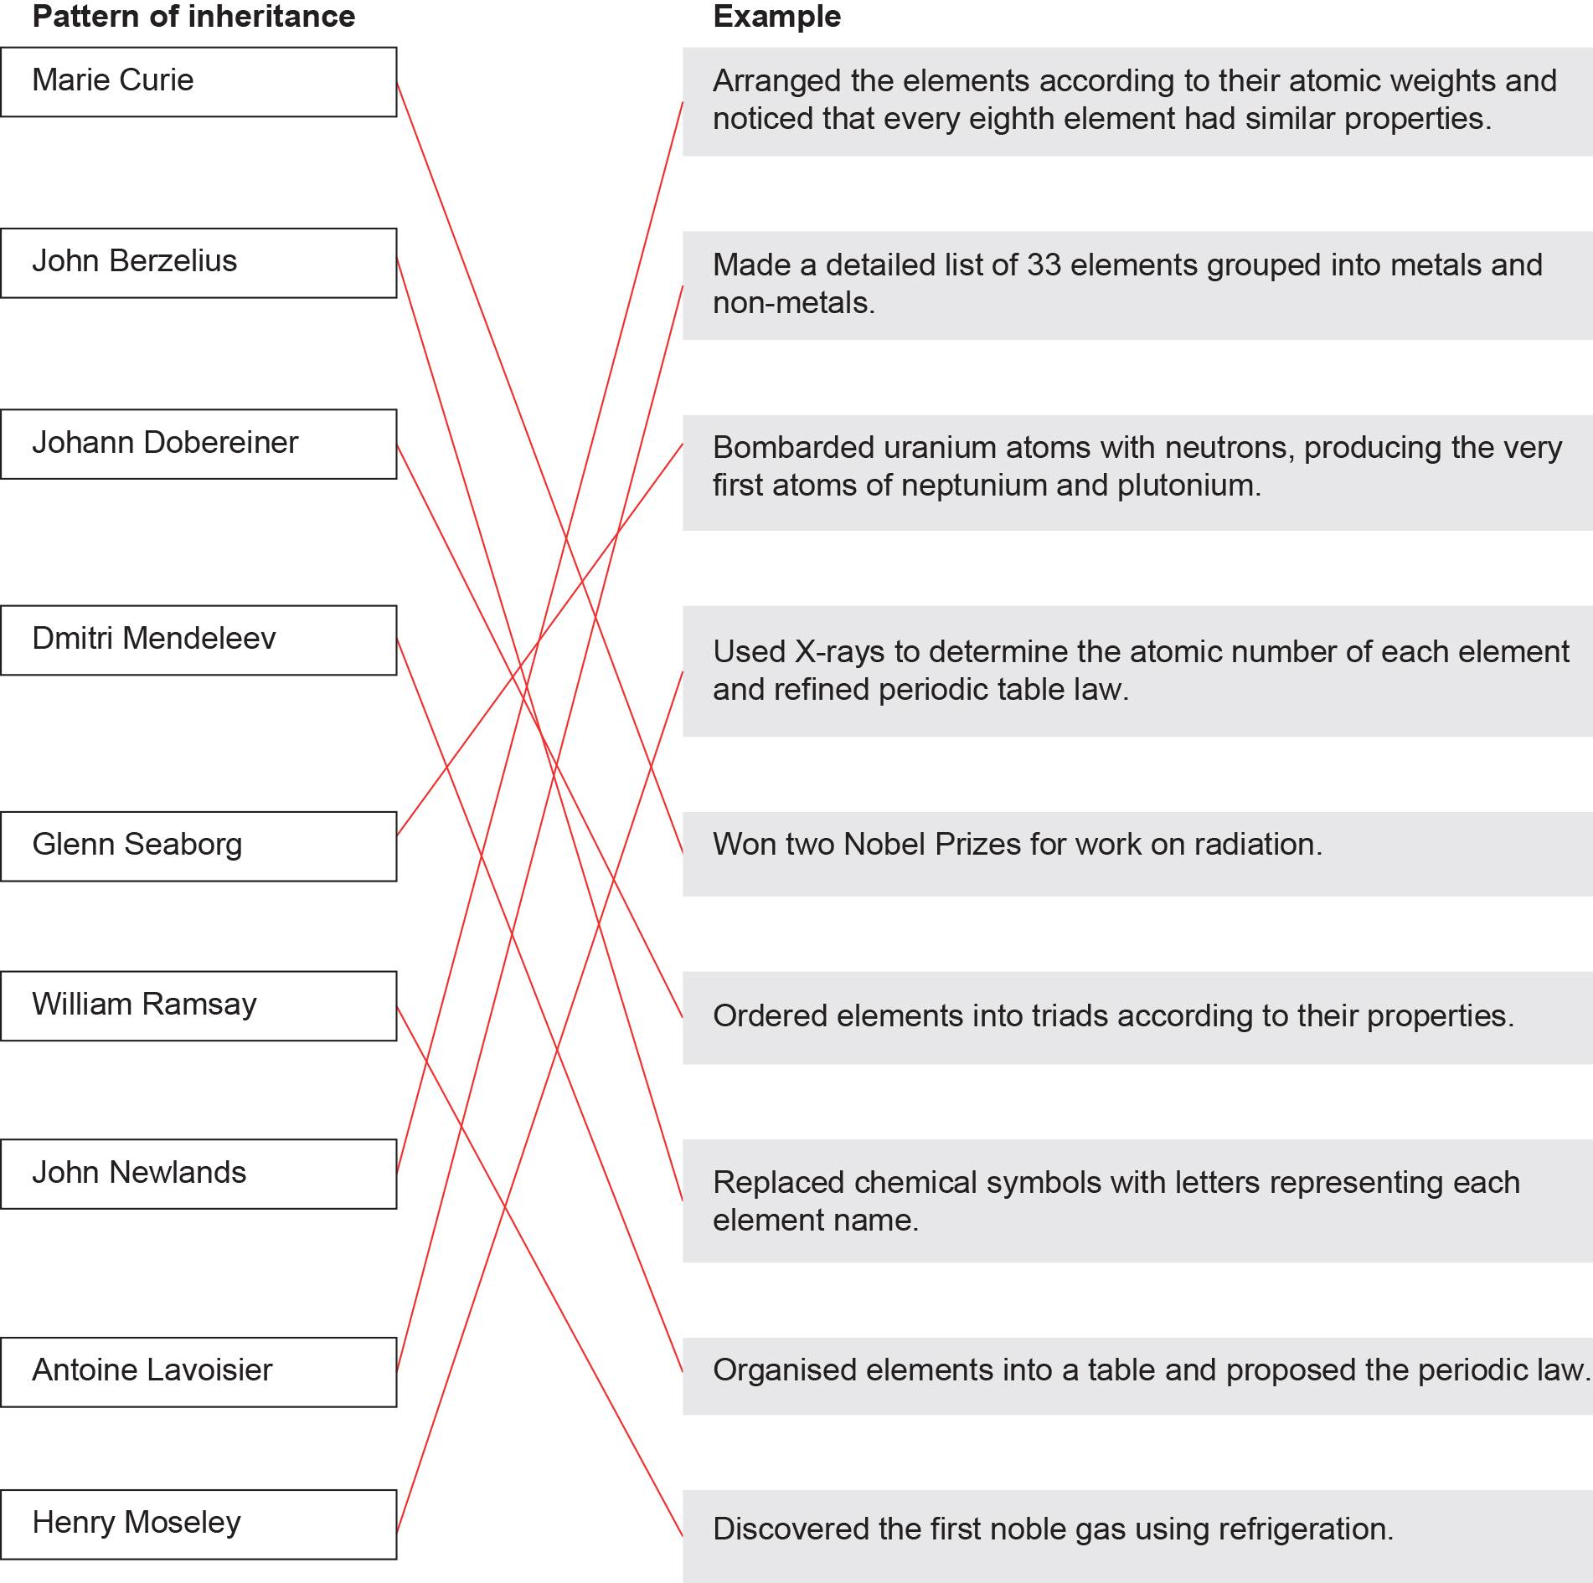

Extend your understanding
5 Research to determine who discovered the following elements, when they were discovered, and how the person made their discovery.
a Cobalt
Georg Brandt, in 1732, showed that cobalt causes the blue colour of glass (not bismuth as was widely believed at the time).
b Hydrogen
Henry Cavendish, in 1766, was the first to identify hydrogen from other gases by reacting strong acids with metals.
c Nitrogen
Daniel Rutherford, in 1772, isolated nitrogen. He removed oxygen and carbon dioxide from air, and named the remaining, isolated gas ‘noxious air’, which we now call nitrogen.
d Helium
Jules Janssen and Norman Lockyer, in1868, observed a yellow line in the solar spectrum that did not match any other element. William Ramsay, Per Teodor Cleve and Abraham Langlet, in 1895, observed an element trapped in cleveite and identified this as helium.

Student worksheet answers

3.2 The structure of an atom determines its properties
Pages 70–73

Atomic structure
1 Complete the following table.

Sub-atomic particle | Mass | Charge | Location in an atom
Proton | 1 | + | Nucleus
Neutron | 1 | Neutral | Nucleus
Electron | 0 | – | Around the nucleus
2 What determines the atomic number of an atom?
The number of protons
3 Why is the atomic number used to order the elements on the periodic table?
Each element has its own number of protons – this does not change. If the number of protons changes, it is considered a new element.
4 What determines the relative atomic mass?
The number of protons plus the number of neutrons (i.e. protons + neutrons)
5 How are electrons arranged in an atom?
In shells surrounding the nucleus
6 What is the outer-most electron shell called?
The valence shell
7 What determines the properties of elements?
The number of electrons in the valence shell
8 On the periodic table, what is a horizontal row called?
A period
9 On the periodic table, what is a vertical column called?
A group

10 For the element fluorine, explain how to use the information in periodic table to calculate
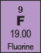
a the number of protons
It is the atomic number = 9
b the number of neutrons
Mass number – atomic number = 19.00 – 9 = 10
c the number of electrons
It is also the atomic number = 9
11 In the Bohr model of electron configuration, what is the maximum number of electrons that can be in the following shells? (Show a formula and calculations for each answer.)
a first shell
2n² = 2 × 1² = 2 × 1 = 2 electrons
b second shell
2n² = 2 × 2² = 2 × 4 = 8 electrons
c third shell
2n² = 2 × 3² = 2 × 9 = 18 electrons
d fourth shell
2n² = 2 × 4² = 2 × 16 = 32 electrons
12 Draw the electron configuration for the following elements.
Nitrogen  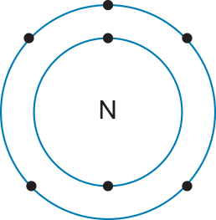  2,5 | Oxygen  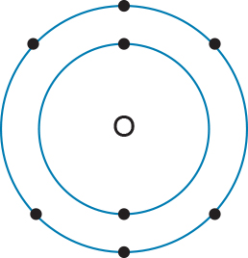  2,6 | Fluorine  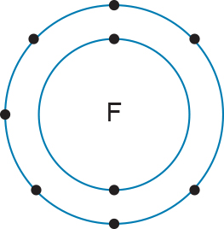  2,7 | Neon  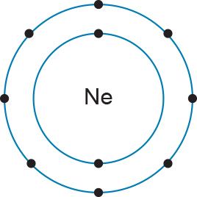  2,8

Phosphorus  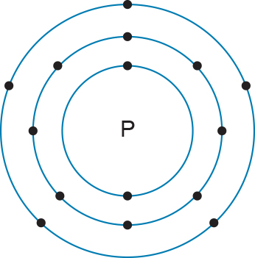  2,8,5 | Silicon  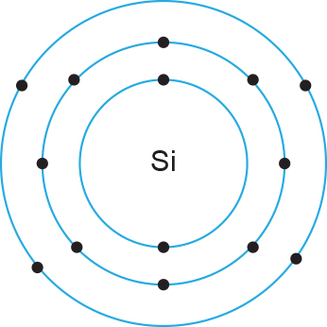  2,8,4 | Chlorine  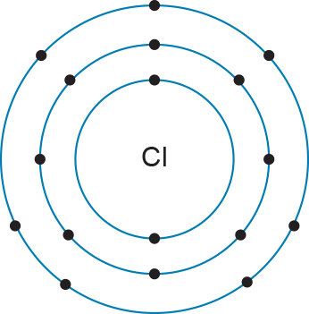  2,8,7 | Argon  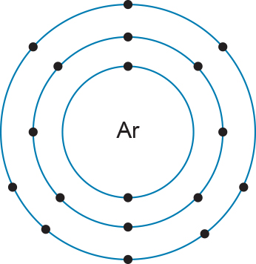  2,8,8
13 Explain the trend in electron shell configuration
a across a period.
The number of valence (outer shell) electrons increases
b down a group.
The number of outer shells increases

Extend your understanding
14 Draw the proposed electron configurations for both of the following atoms using the given configurations.
Potassium:  19 electrons | 2,8,8,1  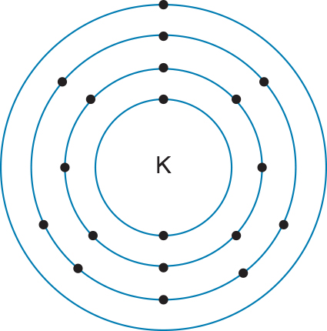 | 2,8,9  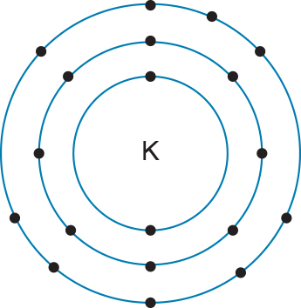
Calcium:  20 electrons | 2,8,10  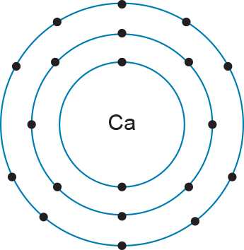 | 2,8,8 2  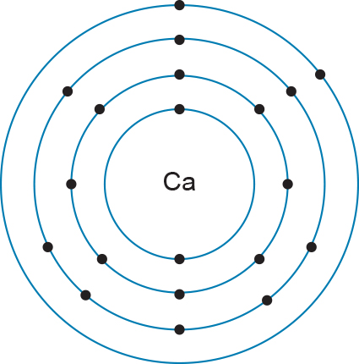
15 Identify which of the electron configurations in the previous question are correct and explain your answer.
The electron configurations that have four electron shells are correct. Once the third electron shell has eight electrons, remaining electrons start moving into the fourth shell. Potassium is in period 4 (= four electron shells) and in group 1 (= one valence electron). Calcium is in period 4 (= four electron shells) and in group 2 (= two valence electrons).
16 Using the knowledge you have gained from this concept, draw the electron configurations of bromide and tin.
Bromine  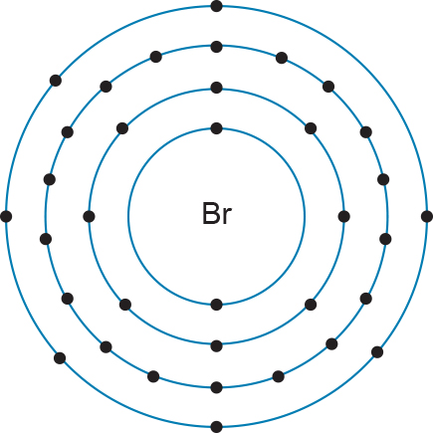  2,8,18,7 | Tin  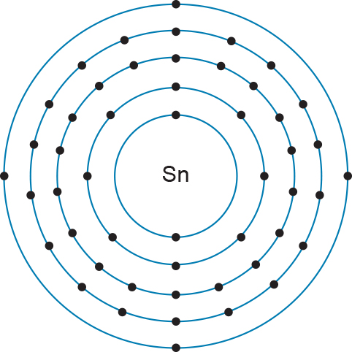  2,8,18,18,4

Student worksheet answers

3.3 Groups in the periodic table have properties in common
Pages 74–75

Trends of metals in the periodic table
1 Name five properties that all metals have in common.
• Lustrous (shiny)
• Able to conduct heat
• Able to conduct electricity
• Malleable (can be beaten into a new shape)
• Ductile (can be drawn into a wire)
2 For the three metal groups in the periodic table, complete the following table.
Name | Alkali metals | Alkaline earth metals | Transition metals
Group number | 1 | 2 | 3–12
Valence electrons | 1 | 2 | Variable
Properties | • Soft  • React with air to become white  • React violently with water to product hydrogen gas and a basic solution  • More reactive down the group | • Low melting points  • Relatively soft and very reactive, although in general they are not quite as reactive as group 1  • React with water, some strongly, producing hydrogen gas and a basic solution  • More reactive down the group | • Some are magnetic  • Gold and copper are the only metals that are not silvery in colour  • Many form coloured compounds  • Many form more than one compound with a non-metal such as chlorine (e.g. iron forms FeCl₂ and FeCl₃)

Extend your understanding
3 Research the structure of metals. For each of the five properties of metals, draw a diagram showing the metal particles that demonstrates how the property occurs. For each diagram, explain what happens to the particles for this property to occur.

Diagram | Explanation
Light reflects off metal due to the electrons  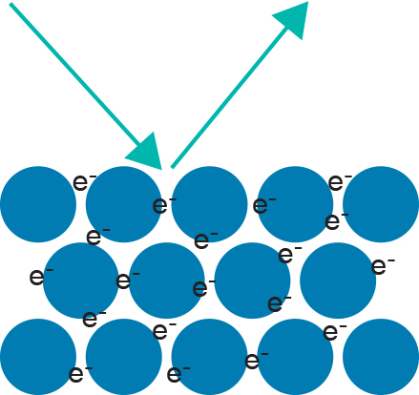 | Metals contain free electrons that vibrate when they come into contact with light, causing them to produce their own light. This light is reflected, creating the shiny, lustrous appearance of metal.
Metal conducts heat due to vibrations of metal particles  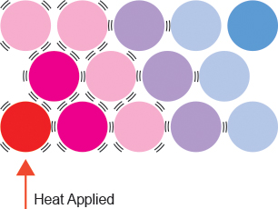 | The heat applied to one end of a metal gives the particles kinetic energy, causing them to vibrate more violently than they normally would. As the particles are closely packed, the vibration is passed on throughout the whole metal. The vibrations are heat energy.
Metal conducts electricity due to movement of electrons  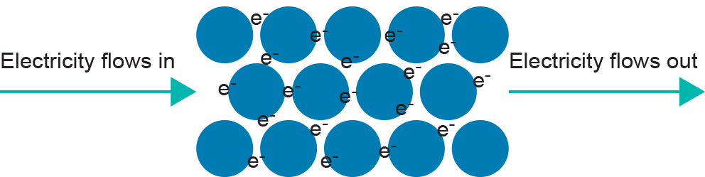 | Free-moving electrons throughout the structure of a metal allows electrons to move through.
Metal is malleable when struck by a hammer  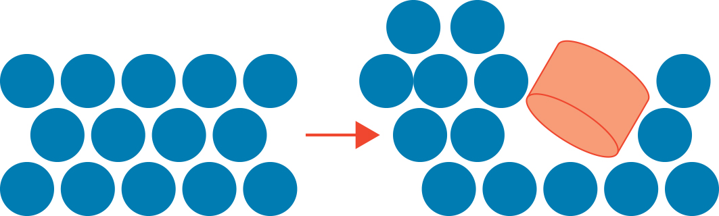 | When struck by a hammer, the metal particles will be pushed into a new orientation by the hammer (by rolling over one another into a new position), without breaking off or detaching.
Metal is ductile and can be stretched from a block into a wire   | As the particles (cations and free-moving electrons) are attracted to one another, the metal can be stretched into a wire without the particles losing contact with one another.

Student worksheet answers

3.4 Non-metals have properties in common
Pages 76–77

Trends of non-metals in the periodic table
1 Name six properties of non-metals.
• Do not conduct electricity or heat well
• Brittle
• Do not reflect light, so they are dull in appearance
• Not ductile (not easily manipulated)
• Have a large range of melting and boiling points
• Some are coloured
2 Which groups of the periodic table are non-metals found in?
Groups 14–18
3 How many elements of the periodic table are non-metals?
18
4 Where would you find non-metals on Earth?
The atmosphere, the Earth’s crust, and living organisms’ tissues
5 Which groups are made entirely of non-metals, what are the names of these groups?
Halogens in group 17, and noble gases in group 18
6 Where are metalloids found in the periodic table?
The small set of elements along the ‘staircase’ between the metals and non-metals
7 Why are some metalloids considered to be semiconductors?
They only conduct electricity in a certain way under certain conditions
8 For the two non-metal groups in the periodic table, complete the following table.
Name | Halogens | Noble gases
Group number | 17 | 18
Valence electrons | 7 | 8

Properties | • Melting and boiling points increase down the group  • It is the only group in which the elements range from gas to liquid to solid at room temperature  • As you go down the group, they are less reactive  • They are sterilising substances because of the lethal effects they can have on bacteria and fungi | • Low melting points  • Have full valence shells so they are unreactive (inert) – xenon and krypton will react with fluorine under certain conditions  • All gases at room temperature  • Radon is the most dangerous as it is a radioactive gas

Extend your understanding
9 Research the structure of metals and non-metals to explain why
a non-metals do not conduct electricity.
Non-metals have no free-moving electrons that allow for the conduction of electricity.
b non-metals are not shiny.
Non-metals have no free-moving electrons to reflect the light that hits the surface of the substance, therefore no light can be reflected back.
c non-metals do not conduct heat well.
Non-metals have no free-moving electrons – the particles are held tightly by the atoms, and the atoms themselves cannot move as freely. Therefore, heat conduction by vibration is more difficult, but still possible (just a lot slower).

Student worksheet answers

3.5 Metal cations and non-metal anions combine to form ionic compounds
Pages 78–79

Ionic compounds
1 What is the difference between an atom and an ion?
Atoms have a neutral charge (the same number of protons and electrons), whereas ions are atoms that have gained or lost electrons and therefore have a charge.
2 What name is given to a metal when it forms an ion, and what type of charge does it have?
Cation: positive
3 What name is given to a non-metal when it forms an ion, and what type of charge does it have?
Anion: negative
4 What is an ionic bond?
An electrostatic interaction between a positive cation and a negative anion
5 An ionic bond is between which two types of elements?
A metal and a non-metal
6 Explain what happens to an ionic compound when it is struck with a hammer. Include diagrams in your explanation.
Before being struck:  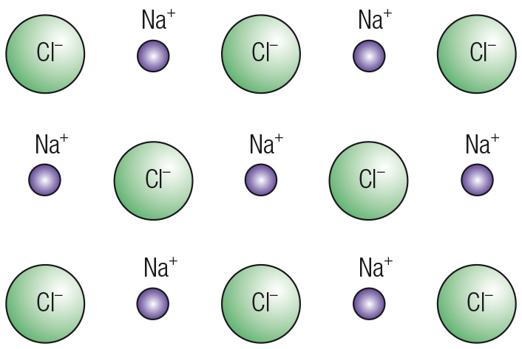 | After being struck:  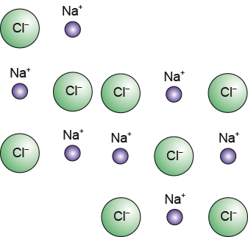
When struck with a hammer, the cations and anions are displaced. A cation may now line up with another cation (as with anions), and repulsion occurs due to the like-charged ions. This causes the compound to become brittle.
7 Complete the following table to demonstrate the number of electrons gained or lost by atoms to form ions.
Group number | Number of valence electrons | Number of electrons gained or lost
1 | 1 | Lose 1
2 | 2 | Lose 2
13 | 3 | Lose 3
15 | 5 | Gain 3
16 | 6 | Gain 2
17 | 7 | Gain 1
18 | 8 | Stable
8 Draw the electron configuration of lithium and fluorine, and then redraw these configurations to demonstrate how an electron is donated between the atoms.
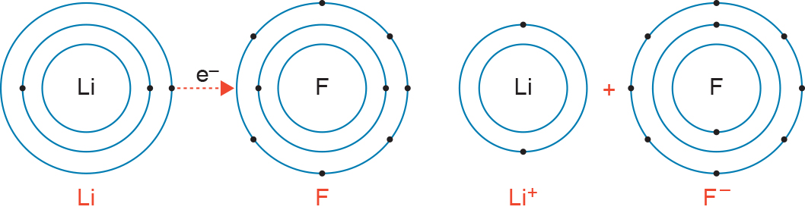
9 Other than being brittle, what is the other main property of ionic compounds? Explain this property.
They have very high melting and boiling points, as the electrostatic attraction that hold ions together is strong.
10 What is a polyatomic ion? Give an example.
Ions that are made up of more than one atom. Examples will vary, such as OH–, NO₃– and CO₃^{2–}.

Extend your understanding
11 Access a valency table (your teacher may have one or you can search for one on the internet). Use the valency table to determine the formulas of the follow ionic compounds.
a Sodium chloride
NaCl
b Sodium nitrate
NaNO₃
c Potassium nitrate
KNO₃

d Calcium hydroxide
Ca(OH)₂
e Aluminium oxide
Al₂O₃
f Hydrogen phosphate
H₃PO₄
g Sodium Hydrogen carbonate
NaHCO₃
h Ammonium hydroxide
NH₄OH
i Sodium sulfate
Na₂SO₄
j Calcium sulfate
CaSO₄

Student worksheet answers

3.6 Non-metals combine to form covalent compounds
Pages 80–81

Covalent bonding
1 Between which types of atoms does covalent bonding occur?
Two non-metals
2 What do these atoms do when they covalently bond?
They share an electron so they both have full valency shells
3 Draw the covalent bonding in the following molecules.

Ammonia (NH₃)  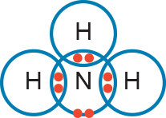 | Methane (CH₄)  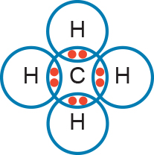
Hydrofluoric acid (HF)  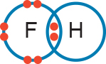 | Carbon tetrachloride (CCl₄)  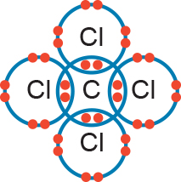
Carbon dioxide (CO₂)  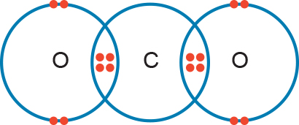 | Phosphorous trifluoride (PF₃)  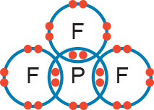

4 What is a diatomic molecule? Give an example.
A molecule that is made up of more than one atom. Examples will vary, such as F₂, Cl₂ and O₂.
5 What is the difference between an atom and a molecule? Give an example.
An atom is singular, whereas a molecule consists of more than one atom. Examples will vary, such as: H is an atom, H₂ is a molecule.
6 Where do electrons reside in covalent bonding?
They exist between the nuclei of the atoms.
7 Why are covalent bonds so strong?
It is the electrostatic attraction between each positively charged nucleus and the negatively charged electrons that they share between them.

Extend your understanding
8 Suggest the most likely chemical formula between the following atoms and draw their covalent bonding.
Atoms | Chemical formula | Diagram
Carbon and fluorine | CF₄ | 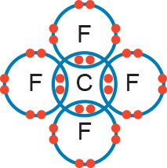
Silicon and oxygen | SiO₂ | 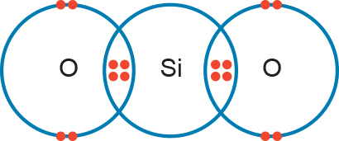
Hydrogen and chlorine | HCl | 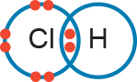
Phosphorous and chlorine | PCl₃ | 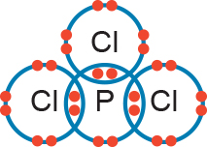
Carbon and sulfur | CS₂ | 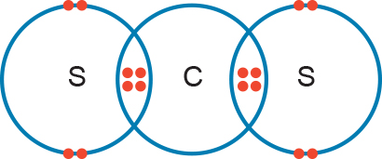

Student worksheet answers

3.7 Metals form unique bonds
Pages 82–83

Metallic bonding
1 What are three of the structural properties that metals have in common?
• Atoms are arranged into layers
• Atoms can slide over one another
• Electrons are delocalised and move freely
2 Where do delocalised electrons come from?
They are the electrons from the valence shell of an atom
3 Why are they referred to as ‘delocalised’?
They are not stuck to a particular atom of locality – they move freely
4 Why are metals able to conduct electricity?
Valence electrons are free to move from nucleus to nucleus along the metal, carrying a charge
5 What is the relationship between temperature and conductivity in metals?
Increased temperatures in metals results in lower electrical conductivity
6 Why are metals shiny?
Delocalised electrons reflect light
7 What is an alloy?
A mixture of two or more metals
8 What are the benefits of using alloys?
They are harder and stronger than pure metals
9 What is a smart alloy?
An alloy that can be heated and cast into a shape that it ‘remembers’. If the alloy is bent out of shape, it can be returned to the original shape.
10 How are the properties of smart alloys beneficial to society?
If it is damaged, heat or electrical current will mould it back into shape. A damaged smart alloy does not need to be replaced, therefore reducing waste and saving money.
11 Explain one use of a smart alloy.
Answers will vary. For example, orthodontic wires will constantly return to their original shape, therefore reducing the need to retighten or adjust the wire.

Extend your understanding
12 An essential tool in chemistry is the process of electrolysis. Conduct some research and answer the following questions:
a What is electrolysis?
The process of running electricity through a compound that is ionic or molten, to turn metal cations into solid metal atoms
b Which scientist paved the way for electrolysis in modern chemistry?
Michael Faraday
c In electrolysis, what does ‘reduction’ mean?
Reduction is the process of reducing the charge on an ion from a higher to a lower number. For example, Cu²⁺ is reduced to Cu.
d In electrolysis, what does ‘oxidation’ mean?
Oxidation is the process of increasing the charge on an ion from a lower to a higher number. For example, Cu is oxidised to Cu²⁺.
e A transformation of energy occurs in electrolysis. What is this transformation?
Electrical energy is transformed to chemical energy
f Why is electrolysis essential to modern society? Name two applications of this process.
Answers will vary. Electrolysis is essential in electroplating where a more expensive and less corrosive metal can coat another less corrosive one. This prevents rusting on objects, such as cars. Electrolysis is also used to convert water into hydrogen and oxygen gas for various purposes.

Student worksheet answers

3.8 Nanotechnology involves the specific arrangement of atoms
Pages 84–85

Nanotechnology
1 What is the diameter of the average atom?
0.3 nanometres (0.000 000 3 millimetres)
2 Why is this an average diameter, and not the diameter of every atom?
Every atom varies in size depending on the number of protons, neutrons and electrons
3 Do you think that this average would more accurately represent the size of a hydrogen, a barium or an ununoctium atom? Explain your answer.
A barium atom, as it is one of the middle atoms on the periodic table, representing the median, which would be closest to the average (the mode).
4 What is nanotechnology?
The manipulation of atoms at the nanoscale to develop technology that can operate at a very small scale, and is therefore more specific in its purpose
5 What scale does nanotechnology use?
The nanometre
6 Give an example of nanotechnology and how it could be used.
Answers will vary. For example, nanobots could be used to boost the immune system, repair parts of the body or clean up the environment.
7 How could nanobots be beneficial to the field of medicine?
Nanobots could constantly look for viruses or bacteria that cause disease. If a virus was detected, the nanobot could break it down molecule by molecule. Some nanobots could carry 9 billion oxygen and carbon dioxide molecules, and could remove the need for blood transfusions in the future.
8 What are the similarities in properties between metals and carbon nanotubes?
Both are extremely hard, have high tensile strength, and are efficient conductors of heat and electricity.
9 What are the differences in properties between metals and carbon nanotubes?
Carbon nanotubes are much lighter and more flexible than metals.

10 Choose two possible applications of nanotubes and explain how they may be of benefit.
Answers will vary. Some examples:
• Clothing – could be damage-proof so there is no wear and tear, therefore reducing clothing costs.
• Computer screens – could create flexible or folding screens with higher resolution than we can currently detect.
• Renewable energy devices – solar panels could generate power and reduce the cost of electricity.

Extend your understanding
11 The buckyball is another example of nanotechnology developed by chemists. Conduct some research and answer the following questions.
a What is the scientific name of a buckyball?
Buckminsterfullerene
b What is a buckyball?
A spherical fullerene molecule (formula C₆₀) that looks like a ball (similar to the shape of a soccer ball). A buckyball can bounce, return to its original shape if squeezed, and spin at amazingly high speeds.
c What is the application of a buckyball?
Although many applications have been speculated, currently no application has been found.
d From your answer to the previous question, explain why you think the buckyball was first synthesised.
Answers will vary. Buckyballs were first synthesised by accident during an experiment with a different aim. This paved the way for further research into carbon nanotubes.

